

Join us as we launch the **S3**Singles Ministry **S**piritual, **S**piritual, and **S**uccessful

**Launch Date**: *(Sunday in September)*

**Place:** Golden Corral *(or another place)*

**Time**: Immediately Following Service

If you are interested in learning more about **S3**Singles Ministry, please see ___________________ or sign up at the welcome center

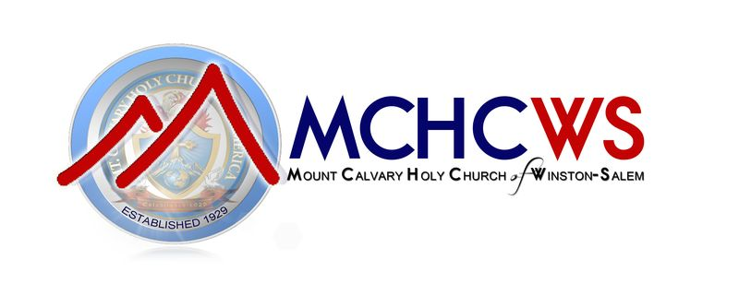

Dr. Tejado W. Hanchell, Senior Pastor

r

Your name might be single…

but you are not alone.

*“Yet I am not alone, for my Father is with me.”*

*John 16:32*